|  |  |
| --- | --- |
| **Networking Infrastructure**  Diploma in CSF/IT  Year 2 (2022/23) Semester 3 | Week **16** |
| 0.5hour |
| **Group Policy – TUTOR GUIDE** | |

1. You provide support for a Windows 2016 network. The network consists of six Windows 2016 server computers and over 100 Windows 10 Professional computers. You want to install the latest service pack to each computer as it logs onto the domain. How can you do this with the least administrative effort?

* 1. Run the service pack individually on each server and computer.
  2. Create a Group Policy to run a Windows Installer package.
  3. Create a login script to install the service pack.
  4. Place the service pack files in a shared folder.

1. The security officer in your company realized that many employees are using simple passwords to access the Windows 2016 domain. He has asked you to suggest a way in which the password security of the network can be improved upon. What is your suggestion?

3. You are the network administrator for a call center company. This network consists of a single AD domain. All servers run Windows Server 2016. The company policy is that all call center users are not allowed to install or run additional applications or to change the desktop settings on their computers. You need to prevent call center users from changing the configuration of the call center computers. Your solution must not restrict users from making changes to computers outside the call center.

What should you do?

* + - 1. Place all the computer accounts for call center computers in an OU named CALL CENTER COMPUTERS. Create a GPO that includes the appropriate restrictions in the Computer configuration section. Link the GPO to the call center computers OU.

(B) Place all the user accounts for call center users in an OU named Call Center users. Create a GPO that includes the appropriate restrictions in the User configuration section. Link the GPO to the call center users OU.

(C) Place all the user accounts for call center users in a security group named Call Center Users. Change the default user rights assignment on the call center computers so that the call center users group has only the Allow log on locally right.

(D) Place all the user accounts for call center users in a security group named Call Center Users. Configure these accounts so that all users use a common roaming profile stored on a file server. Assign the call center users group the Allow-Full control permission for the roaming profile folder.

1. You are the administrator for the corporate.local domain. You created an organization unit structure as shown below. You create a Group Policy called GPOCorp.

GPOCorp has two settings:

* a User Configuration setting to enforce password complexity.
* a User Configuration setting to provide desktop a wallpaper setting.

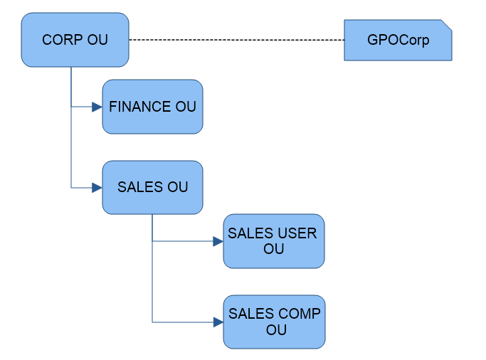

The manager of the sales department now wants to provide a different desktop wallpaper setting for members of the sales department only. All sales department user accounts are in the Sales User OU. How should you configure Group Policy to accomplish this?

**Note:** When you apply a few GPOs at different levels and every GPO has its own settings, all settings from all GPOs are merged and inherited by the computers or users. To resolve the conflict that occurs when two or more settings occur, the order of precedence is as follows:

1. Local Policy

(B) Site GPO

(C) Domain GPO

(D) OU GPO

(E) Child OU GPO

(A) Create a new Group Policy object (GPO) in the Sales User OU that includes the Sales Wallpaper. Block policy inheritance for the new GPO.

(B) Create a new Group Policy object (GPO) in the Sales User OU that includes the Sales Wallpaper. Ensure that policy inheritance is enabled for this GPO.

(C) Create a new Group Policy object (GPO) in the Sales Comp OU that includes the Sales Wallpaper. Ensure that policy inheritance is enabled for this GPO.

(D) Create a new Group Policy object (GPO) in the CORP OU that includes the Sales Wallpaper. Ensure that this policy has priority over the original policy.